Grade level: high school, introductory college
Duration: 90 minutes
Explore sediments:
Changing environments along the Central California coast

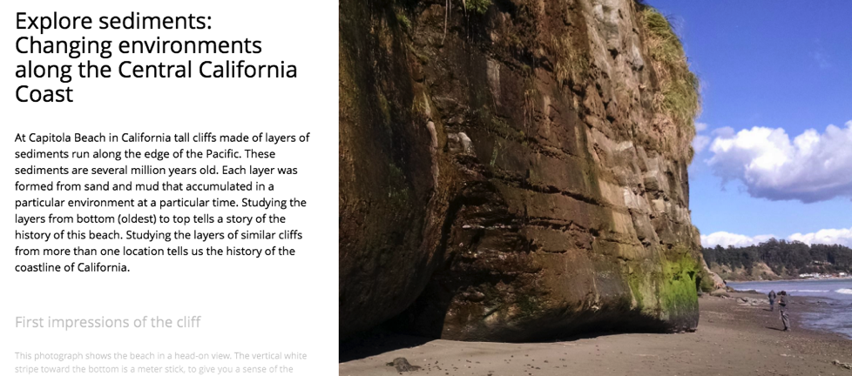

Table of contents
Lesson plan details
Overview
Overarching question
Driving question for students
Module description
Length of activity
Earth science concepts covered
Specific intended learning outcomes
Prior student knowledge
Possible preconceptions and misconceptions
NGSS alignments
Annotated Storymaps module slides
Home slide (Slide 1): Explore sediments: Tales of change in the sediments in cliffs at Capitola Beach
Slides 2 and 3: Observing an outcrop
Slides 6 and 7: Investigating the layers
Slides 8 and 9: Same sea, different place
Slide 10: Getting your nose to the rocks at Moss Beach
Slide 11: Putting all the pieces of the story together

Lesson plan details
Overview
This module introduces students to making sense of the geologic history of a place by doing virtual fieldwork to interpret layered sediments (or sedimentary rocks) at a real outcrop.

The module uses the slides from the Storymap “Explore sediments: Changing environments along the Central California Coast.” Students will also open some images from the Storymap into separate tabs where they can explore them at high resolution. The Storymap is written for students and contains questions to consider, but suggested specific activities are listed in this document rather than integrated directly into the Storymap text (which provides greater flexibility for the variety of audiences who may visit the Storymap).

Of course, just as there are many possible lessons with any real-world outcrop, there are many lessons you might create using the images presented here that go beyond this lesson plan outline.
Overarching question
How do we interpret local Earth history from an outcrop of layered sediments?
Much of what we know about the history of the Earth and its life -- from climate change through geologic time to patterns of evolution and extinction to large scale tectonic changes -- are known from interpreting records of layered sediments. By learning a few basic principles, students can interpret many of the examples of layered sediments they are likely to come across.
Driving question about Capitola and Moss Beaches
What happened here to make some layers look and weather so differently from others?
Deeper questions
● What happened along the Central California coast to make the layers of sediments that we see there?
● Why do the layers look different from the bottom to the top of the outcrops?
● Why do they look different at two beaches along the same coastline that have layers similar in geologic age?

Module description
Explore an outcrop of sedimentary layers in the California South Bay coastal region, exploring the outcrop both from a distance and close-up as one would in the field. Students will learn to read the history of environments in an outcrop. They will notice fundamental patterns in the outcrop (for example, layering), and then make observations of patterns that crosscut or tilt those layers. What was the order of events, and what might the events have been that made this outcrop look as it does?
Length of activity
If done in full may take 90 minutes, but can be adapted to 45 minutes
Earth science concepts covered
● Sediment is generally deposited in flat layers.
● Sedimentary layers can be faulted, tilted, and folded by other geologic processes.
● Sediment, fossils, and other geologic features (such as sedimentary structures and erosion surfaces) can help us understand the environmental history of a place.
● Different types of sediment and the manner in which it is stuck together can affect how it weathers. The hardness and weathering of the layers influences the role it plays as a substrate for modern organisms.
● In summary, an outcrop looks the way it does because of (1) what happened when the sediments/rocks were deposited + (2) what happened to them when they were buried under the surface + (3) what has happened to them since they have become exposed at the surface.
Specific intended learning outcomes
● Students will be able to point out layers, different kinds of sediment, fossils, and other geological structures in an outcrop.
● Students will be able to form a hypothesis, based on sediment and fossil data and basic principles of sedimentation and erosion, that explains what the environment may have been like when an individual layer of sediment was deposited.
● Students will be able to form a hypothesis, based on data such as a set of layers and cross-cutting relationships, that explains the history of the environment in an outcrop.
Earth science concepts covered
● Sediment is generally deposited in flat layers.
● Sedimentary layers can be faulted, tilted, and folded by other geologic processes.
● Sediment, fossils, and other geologic features (such as sedimentary structures and erosion surfaces) can help us understand the environmental history of a place.
● Different types of sediment and the manner in which it is stuck together can affect how it weathers. The hardness and weathering of the layers influences the role it plays as a substrate for modern organisms.
● In summary, an outcrop looks the way it does because of (1) what happened when the sediments/rocks were deposited + (2) what happened to them when they were buried under the surface + (3) what has happened to them since they have exposed at the surface.
Prior student knowledge
● It may be helpful for students to know what a fossil is and to have had a preliminary introduction to types of sediment, deposition in layers, and the principle of superposition.
● It will also be useful for students to understand the idea that marine environments vary with distance from shore and from the mouths of rivers that carry weathered sediment into the ocean.
● Some prior conception that environments and relative sea level can change may also be helpful.

● It will be helpful for students to interpret an environmental block diagrams and cross-sections like this one: 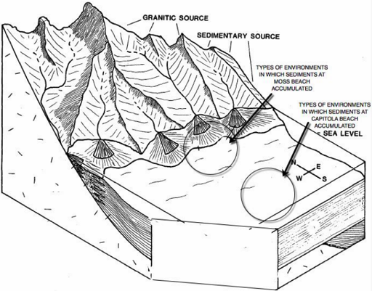
(modified from Wiley and Moore, 1983)

Such diagrams may feel unfamiliar and complex at first. We introduce a 3-D “block” diagram at the start of the Student Guide to help them visualize the coast of California 3 million years ago and put their observations of sedimentary layers into context. In a way, we are giving away the big picture answer to why the sediments look the way they do at Capitola and Moss Beaches, but students will still need to ponder how the sedimentary layers relate to the environments in the block diagram. Their final problem is labeling a cross section (the left face of the block diagram).
Possible preconceptions and misconceptions
● Students might assume that the shape of the outcrops (and local landscape) is related to the history of the deposition of the layers.
● Students may expect to find, and thus interpret, the shapes of some fossils or other features to be dinosaurs or other large vertebrates.
● Students might interpret recent surfaces of the outcrop (weathering, recent biological activity) as records of the geological history.
● Students may be surprised that sediments several million years old containing fossils have not been lithified into rock.
● Students may be surprised that shells that look like modern beach shells, with little obvious alteration other than loss of color, are nonetheless still considered to be fossils.
NGSS alignments
Performance Expectation(s):
● ESS2-2. Analyze geoscience data to make the claim that one change to Earth's surface can create feedbacks that cause changes to other Earth systems.

Science & Engineering Practices: Connections to Nature of Science:
● Science knowledge is based on empirical evidence.
● Science disciplines share common rules of evidence used to evaluate explanations about natural systems.

Disciplinary Core Ideas:
● ESS2.A: Earth Materials and Systems: The geological record shows that changes to global and regional climate can be caused by interactions among changes in the sun’s energy output or Earth’s orbit, tectonic events, ocean circulation, volcanic activity, glaciers, vegetation, and human activities. These changes can occur on a variety of time scales from sudden to intermediate to very long-term tectonic cycles.

● ESS2.E Biogeology: The many dynamic and delicate feedbacks between the biosphere and other Earth systems cause a continual co-evolution of Earth’s surface and the life that exists on it.

Crosscutting Concepts:
● Stability and Change: Much of science deals with constructing explanations of how things change and how they remain stable.

● Cause and Effect: Empirical evidence is required to differentiate between cause and correlation and to make claims about specific causes and effects.

NGSS HS-ESS2-2 evidence statements: Observable features of student performance

1 Organizing data
Students organize data that represent measurements of changes in hydrosphere, cryosphere, atmosphere, biosphere, or geosphere in response to a change in Earth’s surface.
Students describe what each data set represents.

In Purisima Formation “Explore Sediments” students will document their observations of ancient sediments in an outcrop that record changes in the geosphere, biosphere, and hydrosphere.
Observable features of student performance will include the following. Students will:
● observe and explore a gigapixel resolution image of an outcrop;
● draw and describe vertical and horizontal variations in sedimentary texture and layers of an outcrop they visit through a gigapixel resolution image;
● draw and describe fossils in the outcrop;
● draw and describe features of an outcrop, such as fractures and weathering, that formed after the sediments had been deposited.

2 Identifying relationships
Students use tools, technologies, and/or models to analyze the data and identify and describe relationships in the datasets, including:
The relationships between the changes in one system and changes in another (or within the same) Earth system; and
Possible feedbacks, including one example of feedback to the climate.
Students analyze data to identify effects of human activity and specific technologies on Earth’s systems if present.

In Purisima Formation “Explore Sediments” students will use photo-documentation of an outcrop (tools and technologies) and simple models (e.g., principle of horizontality, principle of cross-cutting relationships, relationships between grain size and energy) to document relationships among geologic variables.
Observable features of student performance will include the following. Students will:
● recognize relationships among variables such as grain size, sediment color, existence of fossils, demonstrated in labeled drawings and descriptions; and
● recognize consistent relationships within the outcrop among horizontally layered sediments, tilted sedimentary layers, and vertical fractures, demonstrated in labeled drawings and descriptions.

3 Interpreting data
Students use the analyzed data to describe a mechanism for the feedbacks between two of Earth’s systems and whether the feedback is positive or negative, increasing (destabilizing) or decreasing (stabilizing) the original changes.
Students use the analyzed data to describe a particular unanticipated or unintended effect of a selected technology on Earth’s systems if present.
Students include a statement regarding how variation or uncertainty in the data (e.g., limitations, accuracy, any bias in the data resulting from choice of sample, scale, instrumentation, etc.) may affect the interpretation of the data.

In Purisima Formation “Explore Sediments” students will written explanations and series of drawings to explain interpretations of relationships among variations in the observational data.
Observable features of student performance will include the following. Students will:
● analyze and explain of the order of events that could have yielded the observations of the outcrop in the Purisima Formation;
● analyze and describe uncertainties in interpretations, and suggest additional observations that would help clarify understanding of how the outcrop came to look the way it does; and
● describe limitations in available geological data available at the site for understanding, for example, the exact timing for each geologic process that caused the outcrop to look as it does.

Annotated Storymaps module slides

Blue text is directly from the student worksheet, and black text is the Storymap and annotations for teachers.

This “block diagram” above shows mountains next to the ocean. Gravel, sand, and mud wash down the mountains into streams and then into the ocean. As the water slows down, gravel drops to the bottom, then sand further out, then silt, and finally clay. The sediment moves downslope and away from the shoreline by moving water and gravity. Some of it also moves laterally (parallel to the shore) as well, so that sediment piles up into fan-shaped deposits, which are therefore called submarine (that is, underwater) fans. This may seem complicated, but you’ve probably sand and mud move this way even at tiny scales such as puddles and ponds.

Notice that each slide can be accessed with the vertical column of dots along the left side. The top slide is the “home slide,” represented by the small house icon -- that is slide 1. The first dot is slide 2, and so on.

Home slide (Slide 1): Explore sediments: Tales of change in the sediments in cliffs at Capitola Beach

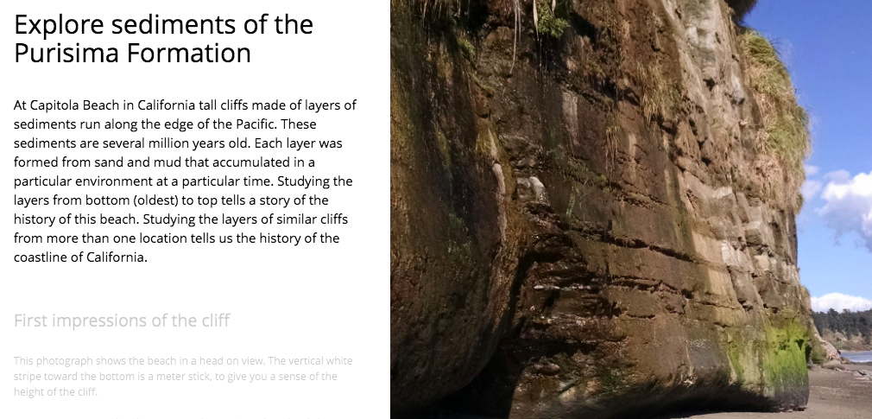

Exploratory activities: If you have time, undertake an activity that allows students to see sediment accumulating in layers. It can be as simple as sequentially adding layers of sand that vary visually into a transparent container filled with water (such as a fish tank or a glass cylinder).

Slides 2 and 3: Observing an outcrop

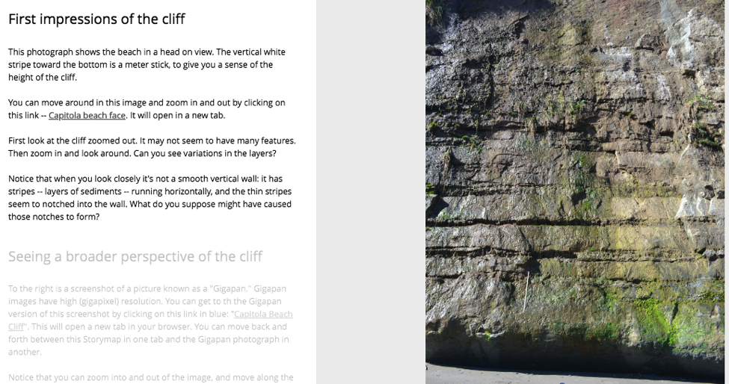

This picture sets the context for slide 3.

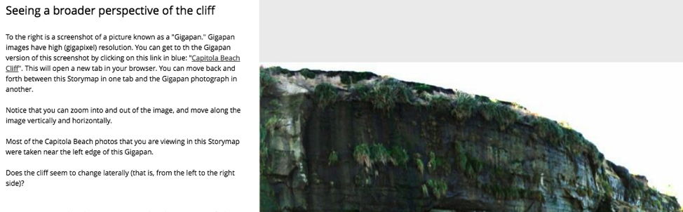

Student guide text:
With the “Gigapan” image in slide 3 (open the link http://www.gigapan.com/gigapans/196382 in a separate window in your browser), you can Zoom in and move around, so that you can investigate the section much like you would if you were physically there. (Some kinds of fieldwork -- like visits to Mars -- are entirely dependent on such photographs.)

Before zooming in, stand back and look at the section. What patterns do you see?

Problem 1a: Document what you observe about the outcrop from a distance.
Draw the outcrop, using the whole piece of paper so you have room for details. Label patterns you notice (but do not write about how you think those patterns formed).

Draw a scale on your diagram. There’s no scale in the Gigapan picture, but one of the broad static images from the same outcrop has a meter-stick in it.

Ask students to document what they observe. There are numerous options:
1) You can ask students to draw the stratigraphic section, labeling patterns that they notice, which is the traditional method for fieldwork.
2) If you have a budget for color copies, you could print copies of the picture of the outcrop and ask students to annotate the copy with arrows, symbols, and labels.
3) If students have the equipment and technical skills, students could download or take a screen grab of the outcrop and annotate in it digitally (e.g., in Powerpoint or Skitch) with arrows, symbols, and labels.
4) You could project the image onto a whiteboard/Smartboard and have students annotate the image during discussion.
Whichever method is chosen, allow the image to be large enough to hold additional details as additional observations are made.
Please note that students should be labeling their diagrams with observations, but not interpretations -- that will come later. (Of course, students will have ideas about what they are seeing, but they should not allow themselves to get locked into seeing what they think they should see based on these initial interpretations rather than what they do see.)

Intended student observations:
layering
incised layers
grasses growing out of certain layers
modest color variations

Note: There’s no scale in the Gigapan picture, but students can also observe a meter stick in slide 2 image from the same outcrop.

Slides 4 and 5: Patterns close-up

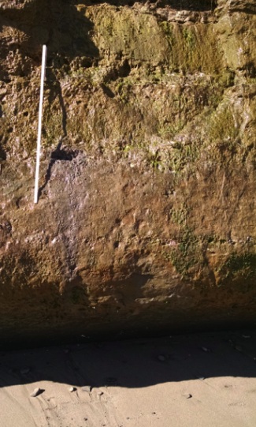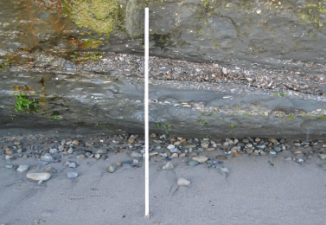

Student Guide text:
You can get a closer view of some of the layers at Capitola Beach using the images in slides 4 and 5, and using the "gigapixel" image to walk up to (zoom into) the outcrop and look around.
What do you notice about the features you saw at a distance when you see them up close?
What other general patterns do you notice when you see the outcrop close up?

Problem 1b: Add additional features of the outcrop to your original drawing, using your observations close-up.

Ask students to add additional features of the outcrop to their original drawing.
● If space is limited, suggest additional drawings linked back, with arrows or codes, to the original stratigraphic section.
● If students have the equipment and technical skills, they can screen grab zoomed in elements, label them, and map them to a large image.

Intended student observations:
sediment appears sandy
layers of various kinds shells
layers tilt and vary in thickness laterally
composition of layers affects weather resistance (though not necessarily in ways that are predictable from the photos; some layers, e.g., are better cemented)

Slides 6 and 7: Investigating the layers
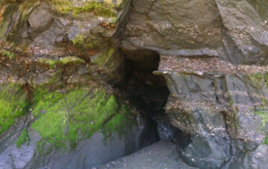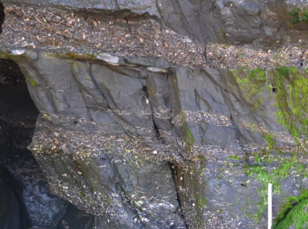

Student Guide text:
If the layers of sediment in cliff wall were the same composition from top to bottom and left to right, it might be difficult to explain why some layers stick out for the wall slightly or are notched back into it or why there are several small caves.

Problem 1c:
● Show how the layers stick out or in with the respect the density of shell accumulation; is the relationship between shelliness and weathering consistent?
● Try to draw the shape of the shells approximately in the orientation you see them in the outcrop.
● Show faults and dipping of beds if you see them.

The purpose of this section is for students to continue their detailed observations of the outcrops, looking specifically at the characteristics of particular layers that relate to interpreting the history of the section and how the history impacts what we see today in the outcrop.

Intended student observations:
layers tilt and vary in thickness laterally
layers stop abruptly where they are interrupted by small faults
composition of layers affects weather resistance (though not necessarily in ways that are predictable from the photos; some layers, e.g., are better cemented)

Slides 8 and 9: Same sea, different place
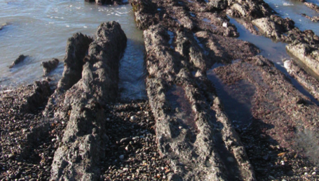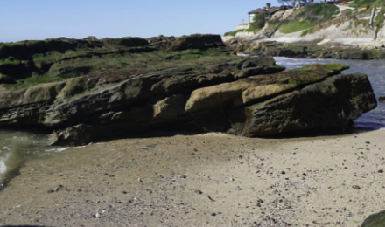

Student Guide text:
At Moss Beach the layers are roughly the same age and in the same coastal sea as at Capitola Beach, but the layers are tilted and folded.

Problem 2a: Based only on what you know so far about the layered sediments at these beaches, provide a brief description of the order of events that must have happened between then and now.

Problem 2b: What other sorts of information would you like to have to be able to flesh out the answer to this question?

It may be helpful to ask students to find Moss Beach on a map and contrast it with the position of Capitola Beach.

Observing a second outcrop from the same sedimentary basin, but a different position in the basin and somewhat different tectonic history, may help students understand how the geologic story of a region or even the Earth is pieced together from outcrops in different locations.

Slide 10: Getting your nose to the rocks at Moss Beach
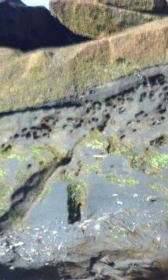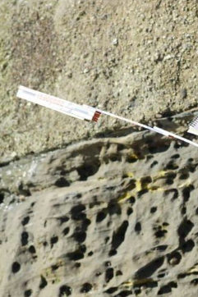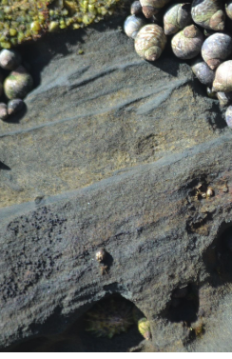

Student Guide text:
Like at Capitola Beach, it’s important to look more closely at the layers to see what they are made of and better understand their origin. At Moss Beach, like at Capitola Beach, there are sandy layers, some rich in marine bivalves. But at Moss Beach there are also layers of sedimentary grains coarser than sand: gravel. You can see in the various images of slide 10 how one of the sandy layers is covered by a gravel layer.

Problem 3: Explain how the grain size of layers at Moss Beach might change from one layer to the next. If you have more than one hypothesis, what information might you seek from the outcrops at Moss Beach that would help distinguish among your ideas?

At Moss Beach students will see layers of shells somewhat like those at Capitola Beach (notice the layer of shells in the image above to the left); these shells represent many of the same species. However, Moss Beach sedimentary layers look different because some of them are composed of much coarser sediment, indicated a relatively nearer shore environment. These coarser sediments are thought to have been deposited in part by sediment flowing downslope by gravity, while the sandy layers may be largely formed by sediment moved by currents. We understand some of these processes because we can modern examples and do laboratory experiments with sediment.

Note that the snails and limpets are responsible for “bioerosion” -- scraping the sediment away, leaving behind the irregular surface.

Slide 11: Putting all the pieces of the story together

(Illustration modified from Wiley and Moore, 1983.)

Student Guide text:
The last slide in the Storymap provides an overall answer to the driving questions: What happened along the Central California coast to make the layers of sediments that we see there? Why do they look different from the bottom to top of the outcrops, and why do they look different at two beaches along the same coastline that have layers similar in geologic age?

To answer these questions (in problem 4 below) imagine that you could make a 2D vertical slice through the Earth from the mountains to the sea. Such a slice is called a “cross-section” and is basically like the left side of the 3D block diagram above.

Problem 4: Draw a cross-section of the California coastline from 3 million years ago, when the sedimentary layers at Moss and Capitola Beaches were accumulating at the bottom of the sea. An example of a diagram of a cross-section is below; you’ll want to make yours large enough to label.

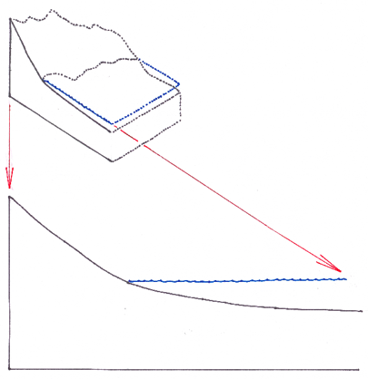

In this capstone activity, students should show that they understand the relationship between the broad explanation for the regional geology and the details of how that history played out to give us the outcrops we see today. They should be able to show in their diagrams:
● How a 2-D cross section is a simplification of a 3-D diagram
● Where the sediments deposited at Moss and Capitola Beaches came from
● Where different kinds of sediment would be found, given our explanatory model and principles of sediment transport

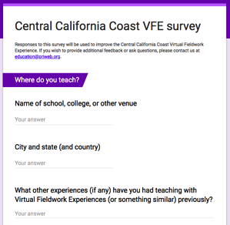
We would be grateful to receive feedback on how we could improve this virtual fieldwork experience. If you can spare about 10-15 minutes, please click here. Thank you very much.

