Explore sediments:
Changing environments along the Central California Coast

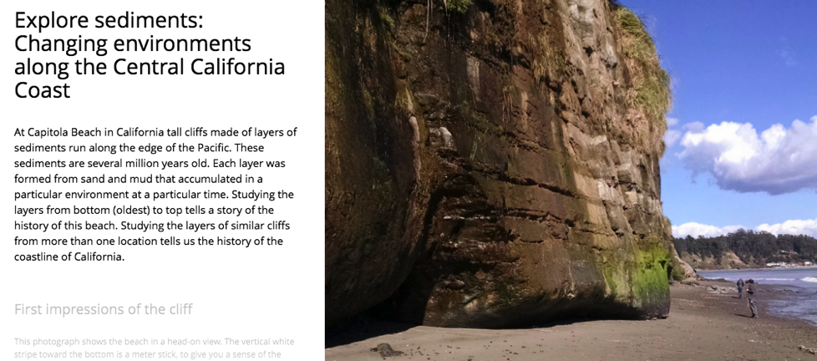
This is the first slide of the Storymap.

Overview
This module introduces you to the environmental history of a place by doing virtual fieldwork to interpret layered sediments (or sedimentary rocks) at a real outcrop.

The module uses the slides from the Storymap “Explore sediments: Changing environments along the Central California Coast” and the Gigapan (gigapixel-size image) “Capitola Beach Cliff.”

Overarching question
How do we interpret local Earth history from an outcrop of layered sediments?
Much of what we know about the history of the Earth and its life are known from interpreting records of layered sediments. By learning a few basic principles, you can interpret many of the examples of layered sediments you are likely to come across.

Driving question at Capitola and Moss Beaches
What happened here to make some layers look and weather so differently from others?

Deeper questions
- What happened along the Central California coast to make the layers of sediments that we see there?
- Why do the layers look different from the bottom to the top of the outcrops?
- Why do they look different at two beaches along the same coastline that have layers similar in geologic age?

Prior knowledge
- It will be helpful for you to know what a fossil is and to have had a preliminary introduction to types of sediment, deposition in layers, and the principle of superposition.
- It will also be useful to understand the idea that marine environments vary with distance from shore and from the mouths of rivers that carry weathered sediment into the ocean.
- It is also helpful to know that environments and relative sea level can change through geologic time.

Before you begin
To figure out what a place was like when ancient sediments and fossils were deposited, we start with knowledge of how sediments and shells accumulate in various kinds of environments today. Since this may be your first experience interpreting layers of sediment, we’ll give you an example below of what someone else thinks was happening along the Central Caifornia coast a few million years ago. You can refer back to this diagram in trying to imagine how the layers correspond to ancient environments.
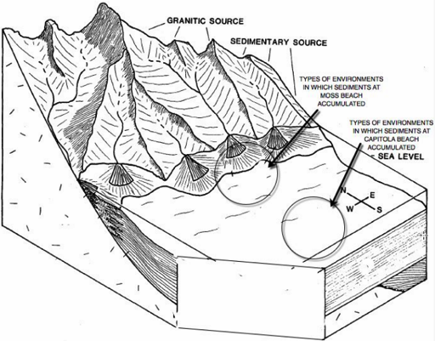(modified from Wiley and Moore, 1983)

This “block diagram” above shows mountains next to the ocean. Gravel, sand, and mud wash down the mountains into streams and then into the ocean. As the water slows down, gravel drops to the bottom, then sand further out, then silt, and finally clay. The sediment moves downslope and away from the shoreline by moving water and gravity. Some of it also moves laterally (parallel to the shore) as well, so that sediment piles up into fan-shaped deposits, which are therefore called submarine (that is, underwater) fans. This may seem complicated, but you’ve probably sand and mud move this way even at tiny scales such as puddles and ponds.

Please read through the Storymap at https://www.arcgis.com/apps/MapJournal/index.html?appid=513b395d422c4c33af30856c577f65e8.
Notice that each slide can be accessed with the vertical column of dots along the left side. The top slide is the “home slide,” represented by the small house icon -- that is slide 1. The first dot is slide 2, and so on.

Slides 2 and 3: Observing an outcrop
With the “Gigapan” image in slide 3 (open the link http://www.gigapan.com/gigapans/196382 in a separate window in your browser), you can Zoom in and move around, so that you can investigate the section much like you would if you were physically there. (Some kinds of fieldwork -- like visits to Mars -- are entirely dependent on such photographs.)

Before zooming in, stand back and look at the section. What patterns do you see?

Problem 1a: Document what you observe about the outcrop from a distance.
Draw the outcrop, using the whole piece of paper so you have room for details. Label patterns you notice (but do not yet write about how you think those patterns formed).

Draw a scale on your diagram. There’s no scale in the Gigapan picture, but one of the broad static images from the same outcrop has a meter-stick in it.

Slides 4 and 5: Patterns close-up
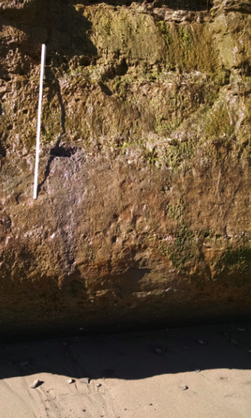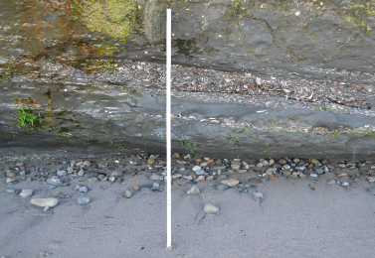

You can get a closer view of some of the lower layers at Capitola Beach using the images in slides 4 and 5, and using the "gigapixel" image to walk up to (zoom into) the outcrop and look around.
What do you notice about the features you saw at a distance when you see them up close?
What other general patterns do you notice when you see the outcrop close up?

Problem 1b: Add additional features of the outcrop to your original drawing, using your observations close-up.

Slides 6 and 7: Investigating the layers
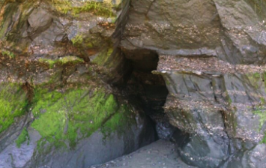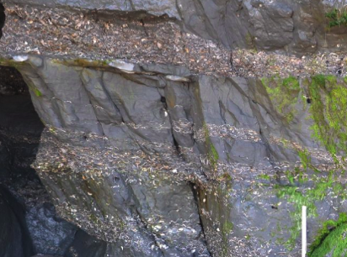

If the layers of sediment in the cliff wall were the same composition from top to bottom and left to right, it might be difficult to explain why some layers either stick out for the wall slightly or are notched back into it, or why there are several small caves.

Problem 1c: Draw a diagram of the cave and sedimentary layers in the image on the right in slide 6. Use other images in slides 6 and 7 if they help with additional detail.
- Show how the layers stick out and how that relates to the quantity of shells (“shelliness”) in the layers; it the relationship between shelliness and weathering consistent?
- Try to draw the shape of the shells approximately in the orientation you see them in the outcrop.
- Show faults and dipping of beds if you see them.

Slides 8 and 9: Same sea, different place
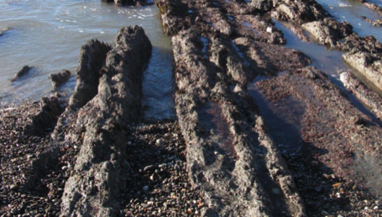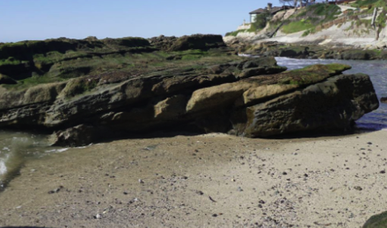
At Moss Beach the layers are roughly the same age and in the same coastal sea as at Capitola Beach, but the layers are tilted and folded.

Problem 2a: Based only on what you know so far about the layered sediments at these beaches, provide a brief description of the order of events that must have happened between then and now.

Problem 2b: What other sorts of information would you like to have in order to more thoroughly answer this question?

Slide 10: Getting your nose to the rocks at Moss Beach
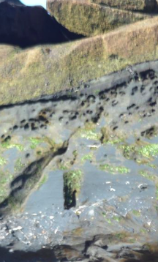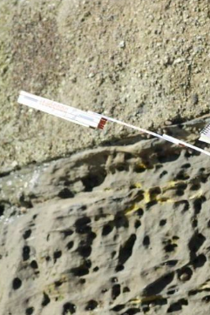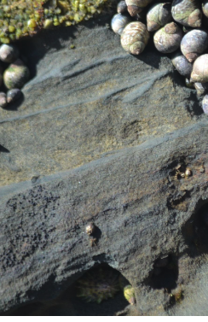
Like at Capitola Beach, it’s important to look closely at the layers to see what they are made of and better understand their origin. At Moss Beach, like at Capitola Beach, there are sandy layers, some containing abundant marine bivalves. But at Moss Beach there are also layers of sedimentary grains that are coarser than sand: gravel. You can see in the various images of slide 10 how one of the sandy layers is covered by a gravel layer.

Problem 3: Explain how the grain size of layers at Moss Beach might change from one layer to the next. If you have more than one hypothesis, what information might you seek from the outcrops at Moss Beach that would help distinguish among your ideas?

Slide 11: Putting all the pieces of the story together
(modified from Wiley and Moore, 1983)

The last slide in the Storymap provides an overall answer to the driving questions: What happened along the Central California coast to make the layers of sediments that we see there? Why do they look different from the bottom to top of the outcrops, and why do they look different at two beaches along the same coastline that have layers similar in geologic age?

To answer these questions (in problem 4 below) imagine that you could make a 2D vertical slice through the Earth from the mountains to the sea. Such a slice is called a “cross-section” and is basically like the left side of the 3D block diagram above.

Problem 4: Draw a cross-section of the California coastline from 3 million years ago, showing the sedimentary layers at Moss and Capitola Beaches when they were accumulating at the bottom of the sea. An example of a diagram of a cross-section is below; you’ll want to make yours large enough to label.

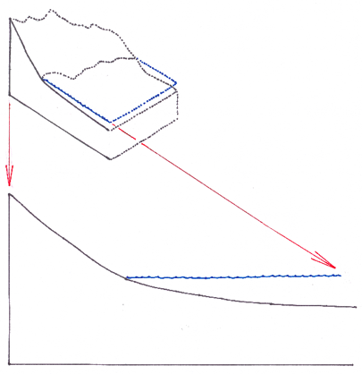
- On your cross-section, label the mountains on the left and offshore to the right. Indicate the present-day positions of Moss Beach and Capitola Beach. (See the block diagram.)
- Indicate where sediments are weathered from bedrock and show the transport of this sediment to the sea bottom.
- Indicate over which area most of the coarse sediment was deposited, and where most of the finer sediments and fossils were deposited.

