Explore Fossils from the Central Coast

Intended audience level: Grades 6-12
Duration: 90 minutes but can be adapted to span two 45 minute activity periods.

Exploring Fossils from the Central Coast is one of three Virtual Fieldwork Experience (VFE) modules that explores the geology and paleontology of the Purisima Formation exposed along the Central Coast of California. The home page of the VFE, including access to other modules, can be found here. The Exploring Fossils VFE is one in a series focusing on classic paleontological field sites and is part of the Eastern Pacific Invertebrate Communities of the Cenozoic (EPICC) Project, funded by the National Science Foundation.

In this virtual visit to two different locations where the Purisima Formation is exposed, students will explore sedimentary rocks rich in fossils and evaluate the evidence supporting claims that changes in environmental conditions in the geological past result in changes in the types and preservation of individual fossil species and fossil assemblages.

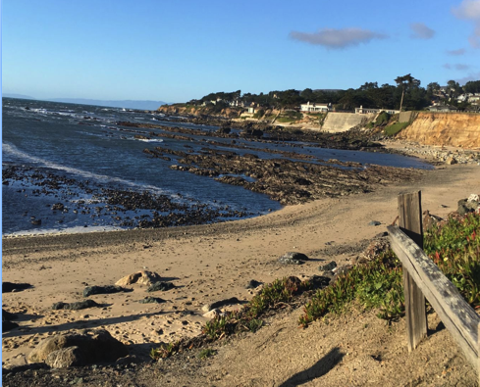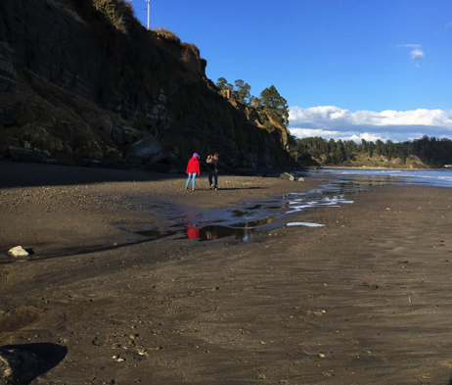

Images of the two beaches visited in this VFE that are introduced in the opening slides of the VFE (Moss Beach, left; Capitola Beach, right).

Table of contents
Explore Fossils from the Central Coast Lesson Plan Details
Overview Overarching question
Driving question for students
Module description
Length of activity
Earth and life science concepts covered Specific intended learning outcomes
Prior knowledge
Possible preconceptions and misconceptions NGSS alignments

Overview
Lesson Plan Details

This module introduces students to fossils found in the Purisima Formation exposed along coastal outcrops in California. It uses photographs, diagrams, and other supporting images to guide students in recognizing characteristic features of fossils within a succession of sedimentary rocks and geological formations in which they are found. Slides from the Story Map, Exploring Fossils from the Central Coast, contain photographs of rocks, embedded fossils, museum specimen photos, and interpretive diagrams to guide students in making observations, asking questions, constructing explanations, and obtaining, evaluating, and communicating information.

Overarching question – check wording in K. Hills guides
How do we use fossils found in sedimentary rocks to determine life in the past and interpret ancient environment of an area? Fossils are the primary means of documenting and understanding life in the Earth’s geological past. Comparing fossils with modern organisms provides evidence and a means to documenting environmental conditions of an area.

Driving question for students
What processes occurred 4 million years ago along the Central Coast of California to deposit shells of marine animals in sedimentary layers that are now exposed in the seacliffs and intertidal zones at the two beaches explored in the VFE?

Module description
By exploring a series of outcrops of sedimentary rocks along the Central Coast as a geologist or paleontologist would in the field, students will learn to observe fossils and interpret what their changes over time mean for the history of an area. Students will be introduced to fossils from common invertebrate groups, and make observations of individual fossils and fossil assemblages the Purisima Formation, a 3-5 million year old geological formation which is exposed in different localities in coastal California. They are asked to observe and document what patterns of change in fossil record are noticeable here and how do the changes guide us in understanding geological change in coastal California (applying the fundamental assumption that natural laws operate today as they have in the past).

Length of activity
The activity may take 90 minutes but can be adapted to span two 45 minute activity periods.

Earth and life science concepts covered
- Fossils are the remains of past life – note this change for other guides
- Fossils change upward in layered sedimentary rocks (strata or stratigraphy) as organisms evolve through time, and characteristic and individual fossil taxa can be used to designate fossil zones (based on the principles of faunal succession; superposition and original horizontality)
- Units can be grouped into formations and mapped based on distinguishing features of rocks and characteristic fossils
- Anatomical similarities and differences between organisms living today and in the past reflects changes in the diversity of fossils through time and documents the evolution and extinction of life
- Fossil assemblages, reflecting populations of organisms that lived millions of years ago, together with the sedimentological features of rocks can be used to interpret past environments.

Specific intended learning outcomes
- Students will be able to describe features within the geological formations they view in the photographs.
- Students will be able to describe specific fossils presented in the different sedimentary layers and record any similarities, differences, or patterns or change through time.
- Students will be able to draw from information on living organisms and modern environments and use this information to interpret what the area looked like in the past and how it has changed over time.

Prior knowledge
- It will be helpful for students to know what a fossil is and to have had a preliminary introduction to sedimentary rocks (see VFE on Explore Sediments). Ask Rob about Molly’s comment, intro to sediments
- Some prior conception of marine environments and familiarity with some modern marine invertebrate organisms is helpful.

Possible preconceptions and misconceptions
- Students might not understand the difference between fossils and rocks.
- Because some fossils resemble modern, extant (living) organisms, students may not be able to distinguish between fossils and their modern counterparts and will be surprised by the age of some fossils.
- Students might think geoscientists' observations directly tell them how things work. Because science relies on observation and because the nature and process of science may be unfamiliar to students, students should be reminded that observation is critical in science but scientists often make inferences about what those observations mean.

NGSS alignments Performance Expectations:
- MS-LS4-1: Analyze and interpret data for patterns in the fossil record that document the
existence, diversity, extinction, and change of life forms throughout the history of life on Earth under the assumption that natural laws operate today as in the past.
- MS-LS4-2: Apply scientific ideas to construct an explanation for the anatomical similarities and differences among modern organisms and between modern and fossil organisms to infer evolutionary relationships.
- HS-LS4-5: Evaluate the evidence supporting claims that changes in environmental conditions may result in: (1) increases in the number of individuals of some species, (2) the emergence of new species over time, and (3) the extinction of other species

Science & Engineering Practices
Connections to Nature of Science:
- Science knowledge is based on empirical evidence.
- Science disciplines share common rules of evidence used to evaluate explanations about natural systems.

Disciplinary Core Ideas:
- LS4.A: Evidence of Common Ancestry and Diversity. The collection of fossils and their placement in chronological order (e.g., through the location of the sedimentary layers in which they are found or through radioactive dating) is known as the fossil record. It documents the existence, diversity, extinction, and change of many life forms throughout the history of life on Earth Science disciplines share common rules of evidence used to evaluate explanations about natural systems.
- Anatomical similarities and differences between various organisms living today and between them and organisms in the fossil record, enable the reconstruction of evolutionary history and the inference of lines of evolutionary descent.
- LS4.C: Adaptation: Evolution is a consequence of the interaction of four factors: (1) the potential for a species to increase in number, (2) the genetic variation of individuals in a species due to mutation and sexual reproduction, (3) competition for an environment’s limited supply of the resources that individuals need in order to survive and reproduce, and (4) the ensuing proliferation of those organisms that are better able to survive and reproduce in that environment.

Crosscutting Concepts:
- Patterns: Patterns can be used to identify cause and effect relationships
- Cause and Effect: Phenomena may have more than one cause, and some cause and effect relationships in systems can only be described using probability

NGSS MS-LS4-1 Evidence statements: Observable features of student performance

- Organize the given data
  - Students use graphical displays (e.g., tables, charts, graphs, and images) to organize given data, including data about:
    - Fossils of animals
    - Fossils of plants
    - The relative ages of fossils
    - Existence of modern counterparts to the fossilized plants and animals and information on where they currently live

In “Exploring Fossils from the Central Coast”, students will document their observations of ancient fossils in an outcrop to records changes in their sizes, shapes, and traits. Student performance should be observable. Students will:
- explore fossils within a gigapixel resolution image

- describe written descriptions of fossils in the outcrop
- draw and describe sizes, shapes, and traits, in order to better understand ancient animal life and their modern equivalents
- observe and describe ancient and modern environments where invertebrate animals live

- Identifying relationships
  - Students identify and describe relationships in the data, including:
    - That fossils represent plants and animals that lived long ago
    - The relationships between the fossils of organisms and the environments in which they lived (e.g., marine organisms, like fish, must have lived in water environments).
    - The relationships between types of fossils (e.g., those of marine animals) and the current environments where similar organisms are found.

In “Exploring Fossils from the Central Coast” students will use photo-documentation of fossils in an outcrop, museum specimens, and modern invertebrate equivalents to document relationships among fossils in the Purisima Formation.
Student performance should be observable. Students will:
- label drawings and write descriptions that show recognition of any similarities or differences among individual fossil traits;
- label drawings and write descriptions that show changing fossil assemblages occurring in the rock layers in the Purisima Formation outcrops;
- describe features, environments, and habitats of modern invertebrates and how they relate to their fossil counterparts.

- Interpreting data
  - Students analyze and interpret the data to determine evidence for the existence, diversity, extinction, and change in life forms throughout the history of Earth, using the assumption that natural laws operate today as they would have in the past. Students use similarities and differences in the observed patterns to provide evidence for:
    - When mass extinctions occurred
    - When organisms or types of organisms emerged, went extinct, or evolved
    - The long term increase in the diversity and complexity of organisms on Earth

In “Exploring Fossils from the Central Coast”, students will produce written explanations and series of drawings to explain and interpret variations in the observational fossil data. Student performance should be observable. Students will:

- describe individual fossils founds in the Purisima Formation at each beach
- describe the fossil assemblages (groups of fossils) that are typical at each beach
- compare the fossils found in the field with museum specimens
- explain the changing diversity of fossils through time

MS-LS4-2: Evidence statements: Observable features of student performance

1. Articulating the explanation of phenomena – see Wayne A. trilineata suggestions
- Students articulate a statement that relates a given phenomenon to scientific ideas, including the following ideas about similarities and differences in organisms and their evolutionary relationships
- Anatomical similarities and differences among organisms can be used to infer evolutionary relationships, including: a) Among modern organisms and b) Between modern and fossil organisms.
- Students use evidence and reasoning to construct an explanation for the given phenomenon.

In “Exploring Fossils from the Central Coast”, students will produce written explanations to explain similarities and differences in invertebrate organisms found in the Purisima Formation and their evolutionary relationships. Student performance should be observable. Students will:
- describe specific fossils found in the Purisima Formation (clams, snails, etc.) and explain how their sizes, shapes, and traits change through time
- explain the causes driving the changes observed in the fossils in the formation
- describe the similarities and differences between the fossils preserved in the outcrop sections, the museum specimens, and their modern (living) equivalents
- describe what happens to the shells during the burial process to result in the preservation observed - see Wayne’s comments

- Evidence
- Students identify and describe evidence (e.g. from students own investigations, observations, reading material, archived data, simulations) necessary for constructing the explanation, including similarities and differences in anatomical patterns in and between:
- Modern, living organisms (e.g., skulls of modern crocodiles, skeletons of birds; features of modern whales and elephants)
ii. Fossilized organisms

In “Exploring Fossils from the Central Coast”, students will use photo-documentation and their own drawings of fossils from the outcrop, museum specimens, and modern invertebrates equivalents to document variations in fossil and modern life forms. Student performance should be observable. Students will: - discuss with Wayne including fossil preservation
- label drawings and write descriptions that show recognition of any similarities or differences among anatomical features and individual fossil traits
- compare the preservation (or condition of) fossil shells from the outcrop photos to museum specimens photos
- analyze the evidence used and construct an explanations for what occurs during the preservation process

- Reasoning
- Students use reasoning to connect the evidence to support an explanation. Students describe the following chain of reasoning for the explanation:
- Organisms that share a pattern of anatomical features are likely to be more closely related than are organisms that do not share a pattern of anatomical features, due to the cause and effect relationship between genetic makeup and anatomy
ii. Changes over time in the anatomical features observable in the fossil record can be used to infer lines of evolutionary descent by linking extinct organisms to living organisms through a series of fossilized organisms that share a basic set of anatomical features

I think this needs to be omitted

In “Exploring Fossils from the Central Coast”, students will produce written explanations drawing on evidence supported by observations of features and patterns in invertebrate organisms found in the Purisima Formation. Student performance should be observable. Students will:
- analyze the anatomical features observed in the fossils from the two Purisima locations
- interpret the evidence supporting changes in shell preservation after the animals died and their shells were buried

NGSS HS-LS4-5: Evidence statements: Observable features of student performance

- Identifying the given claims and evidence to be evaluated – note some formatting things in this section
a. Students identify the given claims, which include the idea that changes in environmental conditions may result in:
    - Increases in the number of individuals of some species;
    - The emergence of new species over time; and iii.The extinction of other species.
  - Students identify the given evidence to be evaluated

In “Exploring Fossils from the Central Coast”, students will produce written explanations identifying the evidence drawn from fossils found in the Purisima Formation supporting the changes in species over time. Student performance should be observable. Students will:
- document changes in the individual species and assemblages in the Purisima Formation that lead to claims and interpretations of changing environmental conditions in the geological past
- apply information from observations of modern marine organisms to the interpretation of habitats of fossil organisms
- evaluate the claims supported by evidence from the fossil and modern invertebrates asserting changing environmental conditions over millions of years of geological time

- Identifying any potential additional evidence that is relevant to the evaluation
  - Students identify and describe additional evidence (in the form of data, information, models, or other appropriate forms) that was not provided but is relevant to the claims and to evaluating the given evidence including:
    - Data indicating the change over time in: a) The number of individuals in each species;
b) The number of species in an environment; and c) The environmental conditions.
    - Environmental factors that can determine the ability of individuals in a species to survive and reproduce

In “Exploring Fossils from the Central Coast”, students will research additional sources of information (scientific publications, web resources, video clips) and gather evidence in support of the claims and interpretations of past environments of the Central Coast of CA over the past 5 million years. Student performance should be observable. Students will:
- describe the data from additional sources of information that draw from models of environmental conditions in Central Coastal California during the Pliocene-Pleistocene
- identify data and data sources that aid in evaluating and understanding the relationships between environmental and habitat change, species interactions, biodiversity, and evolution and extinction
- evaluate all available data in the VFE (sedimentary rocks associated with each formation, fossil assemblages in each of the zones, size changes in fossils through time) and other sources in support of claims and interpretations of sea level change in Central Coastal California.

- Identifying any potential additional evidence that is relevant to the evaluation – more formatting things here
  - Students identify and describe additional evidence (in the form of data, information, models, or other appropriate forms) that was not provided but is relevant to the claims and to evaluating the given evidence including:
    - Data indicating the change over time in: a) The number of individuals in each species;
b) The number of species in an environment; and c) The environmental conditions.
    - Environmental factors that can determine the ability of individuals in a species to survive and reproduce

Questions and guide to the Exploring Fossils of the Central Coast module

The Exploring Fossils module has 19 slides (some with multiple images) with guided questions that are grouped as follows:

Slides 1- 4: Observing features of the modern beach and gathering data
Slide panels 1-4, collectively, serve as an introduction to some basic geological concepts that are helpful to understanding fossils in the Purisima Formation. Because a significant number of technical terms are introduced, including formal and informal fossil names, students are encouraged to write the definition of the following terms using the glossary provided. These terms can later be incorporated into answers to subsequent questions.

outcrop | sedimentary rocks | evidence | evolution | extinction
gastropod | bivalve | assemblage | preservation | fossil
erosion | sand | Purisima Formation | beach | habitat

In the photographs of Moss Beach (left) and Capitola Beach (right), students are asked to describe the general features of the beach and note what scientists might be observing and what are some of the questions they might ask while at the beach. What are the similarities and differences between the two beaches?

We recognize students may not have studied the technical features of beaches or sedimentary rocks prior to this exercise or have the vocabulary to provide detailed answers. Simple observations of the presence of cliffs, sand, water and waves at the beach, the color of the sand, and grain sizes that range from large to and small. At Moss Beach (left photo) the sand appears to be a lighter color and there is the notable presence or rocks in the water. At Capitola Beach there appears to be a stream cutting through the beach area and, overall, the beach appears flatter. The photographs where taken in March 2017 and beaches change daily, seasonally, and annually. If students are interested in exploring beaches further and how beach profiles change as a natural consequence of coastal erosion, they can explore this site.

As scientists take a closer look at the modern/present-day beach and examine features in the cliff behind the beach, we ask students to put themselves in the shoes of a scientist. (1) What questions might the scientists be asking? (2) What are they observing? (3) What evidence might they be collecting? As the VFE shifts attention from the modern beach to the rocks in the cliffs behind the beach, students are asked to describe what kinds of fossils they see in the sedimentary rocks and other features they notice.

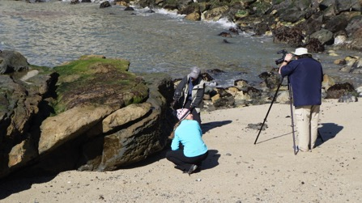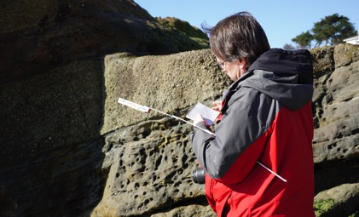

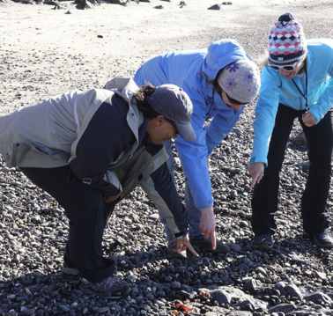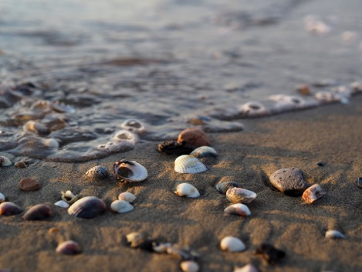

Before the VFE shifts to examining fossil specimens from the UC Museum of Paleontology collection as a guide to compare with fossils in the field, students are asked to make some initial observations of the fossils in the Purisima Formation at Capitola Beach:

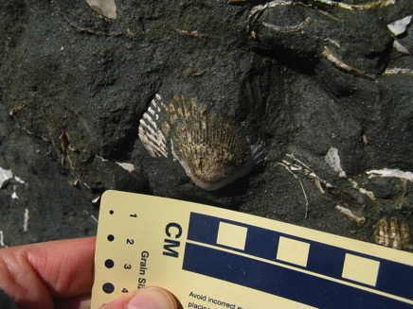
Questions for students
(1) How many shells do you see in the photograph?
(2) How many whole shells? How many fragments?
(3) Do you recognize any of the shells, can you name the type of animal is represented by the fossils?

The students should note there is a whole clam in the photograph and more than a dozen shell fragments around the whole shell.

Slides 5-10: Examining museum specimens from the Purisima Formation
In slide panels 5-10 students are asked to look at fossils from museum collections taken from the Purisima Formation in order to familiarize themselves with the main shells features so that later they can recognize some of these shell fragments in outcrop photos.

Students are not expected to know or use technical terms when identifying shell features; they can use their own words to describe if a shell is smooth or rough, has bumps, folds, or knobs, has a round shape, etc. The goal is for students to notice that each of the fossils shells have distinguishing features. If we see fragments of fossil shells in the field, often times we can we tell which fossil it is if some of the distinguishing features are viewable in the outcrop. The museum specimens are distinguishable by genus and species and students are instructed as follows:

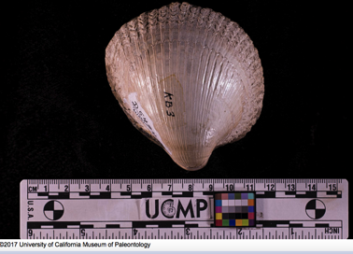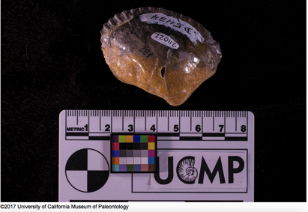

The scientific name of the clam on the left is Laevicardium meexianum and on the right is Anadara trilineata. Sketch and describe (in your own words) some common features of the shell.

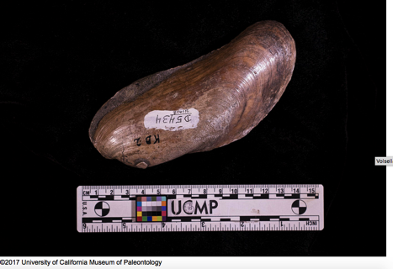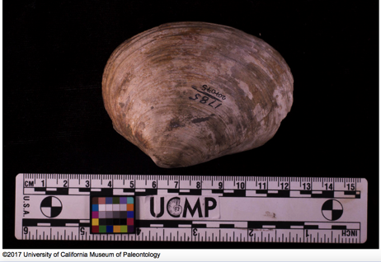

The scientific name of the clam on the left is Volsella flabellate and on the right is Tresus pajaroanus. Sketch and describe (in your own words) some common features of the shell.

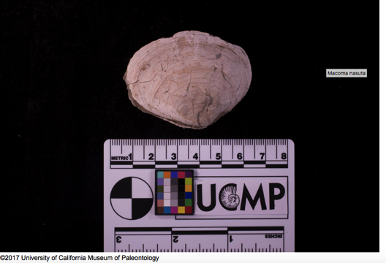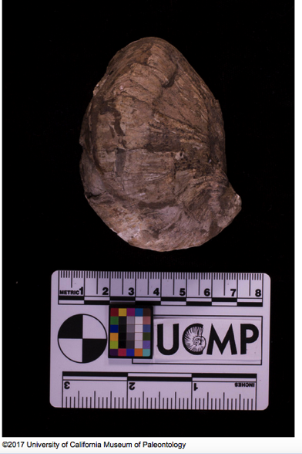

The scientific name of the clam on the left is Macoma nasuta and on the right is Crepidula praerupta. Sketch and describe (in your own words) some common features of the shell.

Slides 11-14: Gathering evidence from the seacliffs

Now that the students have familiarized themselves with common fossils from the Purisima Formation and the overall features of the beaches, we ask them to return to the beach for a closer examination of the Purisima Formation.

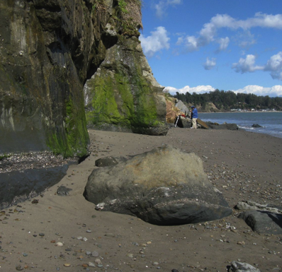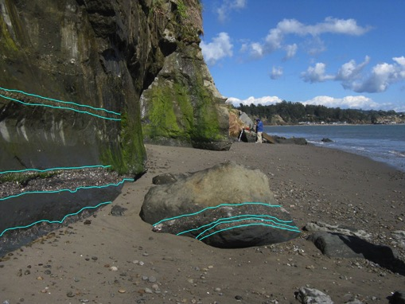

Students are asked first about the photograph shown above left. Where should they look for fossils in the cliffs and why?

Students are then presented with the photograph shown above right with the layers defined by the blue lines. With attention drawn to these layers, students are asked why some layers have more or less fossils and are encouraged to ponder the following questions related to photographs shown in slide panels 13 and 14. Sketches are encouraged to keep track of whole and fragmented shells, and to help students notice shell characteristics that may help them match fossils to the museum specimen shells

- Do you recognize some of the shell forms in the Purisima rocks from the museum specimens?
- Sketch the whole and fragmented fossils that you see and describe any features you recognize
- Reflect on the environmental processes that might be responsible for forming what you see in the rock.

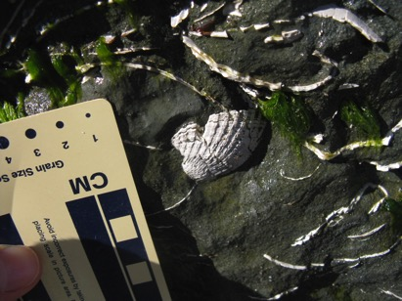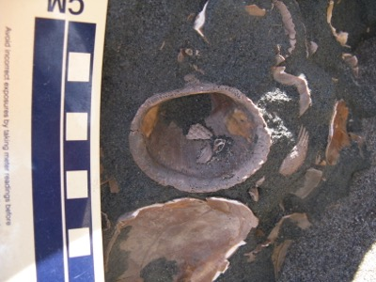

Photographs from slide panel 13

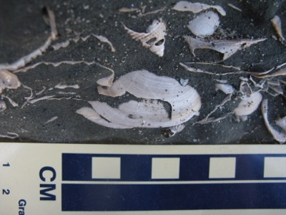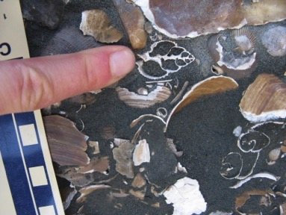

Photographs from slide panel 14

Slide 15: Living organisms and their habitats

Part of understanding fossils is comparing them to living organisms and living habitats. A short video of a burrowing clam and a picture from Moss Beach of a fossil clam in a burrowing position are designed to help students visualize how shells become buried or encased in sedimentary rocks.

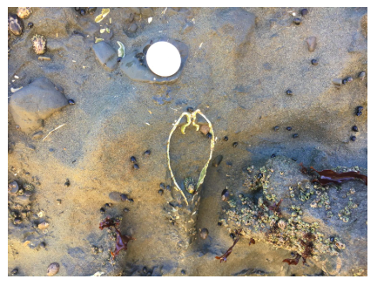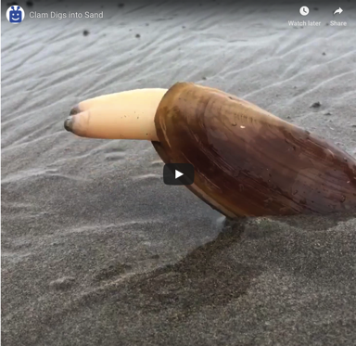

Slide 16: Fossil burial and shell fragmentation

Students are asked to observe what happens to shells and other hard parts upon burial using sketches in the diagram below. They can compare the sketches to drawings they made of fossils in the Purisima Formation to help explain the fragmentation of shells. The diagram is useful because it details the initial steps in the breakdown of hard parts of organisms (the source of the image is an older UC Berkeley website that details other aspects of fossil preservation, https://uccforams.wordpress.com/2014/03/07/taphonomy/)

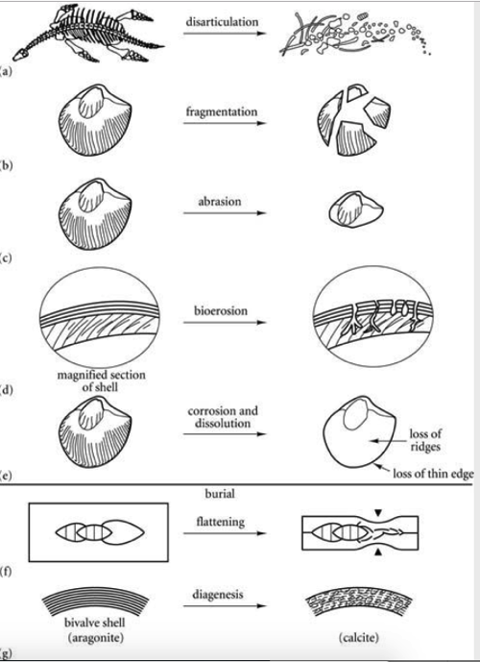

Diagram from slide panel 16.

Slide 17: Fossil preservation
In order to further student understanding of (1) fossil preservation, (2) burial of shells in sediment, and (3) the eventual breakdown and subsequent transportation of shell material, students are encouraged to visit the Digital Atlas of Ancient Life website to gain further perspectives on fossil preservation. By looking at 3D images of fossils and various states of preservation, students should be able to articulate at the conclusion of the VFE exercise, how the fossils in the Purisima Formation came to be.
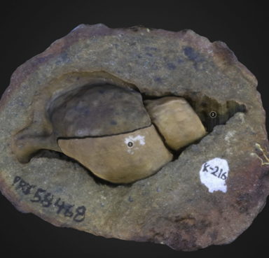
http://www.digitalatlasofancientlife.org/vtc/preservation/
https://skfb.ly/6ArNo
https://skfb.ly/6AWPx

Gastropod cast and mold from the Digital Atlas of Life website

Slide 18: Fossil preservation in the Purisima Formation

In the final part of the VFE, students are shown an additional photo of fragmented fossils from the Purisima Formation. They are encouraged to view a video of waves on a beach transporting sand and shells, https://youtu.be/LSJp6avkvWc. Together with supporting evidence presented throughout the VFE, they should be able to provide an overall summary how the sediments that eventually formed the Purisima Formation preserved fossil shells. Additional information on the history of the sediments and the overall geology of coastal California can be gathered from the Explore Sediments and Explore Geology virtual field experiences.

Slide 19: Summary with the scientists

The EPICC VFE team filmed a number of segments while working in the field at Moss Beach and Capitola, California. Links to a few of the video clips on the UC Museum of Paleontology YouTube channel are in the last slide panel. The scientists describe features in the rocks and fossils, discuss explanations for why the rocks look they way they do, and talk about some of the tools we use in the field to photograph and capture key details of the geology of the area.

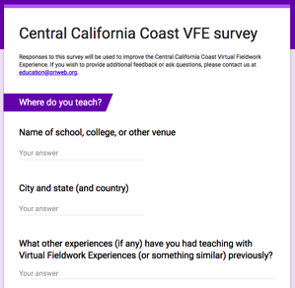
We would be grateful to receive feedback on how we could improve this virtual fieldwork experience. If you can spare about 10-15 minutes, please click here.
Thank you very much.

