Explore Fossils - Past lives of the Kettleman Hills

"Explore Fossils" is one of five Virtual Fieldwork Experience (VFE) modules that explores the geology and paleontology of the Kettleman Hills, which sit on the western edge of California's Central Valley. The home page of the VFE, including access to other modules, can be found here. The Explore Fossils VFE is one in a series focusing on classic paleontological field sites and is part of the Eastern Pacific Invertebrate Communities of the Cenozoic (EPICC) Project, funded by the National Science Foundation.

In this virtual visit to the Kettleman Hills, you will explore sedimentary rocks rich in fossils and evaluate the evidence supporting claims that changes in environmental conditions in the geological past result in changes in the types of individual fossil species and fossil assemblages.

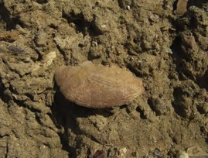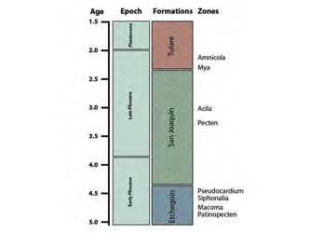
You’ll find this image of a fossil sand dollar in sandstone from the Etchegoin Formation and the diagram showing the three main formations in the Kettleman Hills area and the fossil zones. Use the tables and boxes provided to record your answers as questions are posed related to features and fossils within the zones as you work through the module. Learn more about the fossil zones from video of Lisa White.

When technical and scientific terms are introduced, use the online glossary to define the terms write their definitions in the following table. Additional terms are defined throughout the
exercise but defining these terms now will be helpful in including them into answers in questions throughout the exercise.

Term | Definition
outcrop
sandstone
evidence
evolution
extinction
echinoderm
bivalve
scallop
barnacle
assemblage
zone
formation
Etchegoin Formation
San Joaquin Formation
Tulare Formation

On the following pages, use the boxes provided for sketches of fossils, features of the outcrop, and/or for written explanations to questions asked about each of the fossil zones

Fossils of the Patinopecten Zone
How many fossils are visible in the photographs of the zone and what do they look like? Can you see any features on the shells or identify any types of familiar animals? Look at the rocks surrounding the fossils. What do you notice about these rocks in terms of color, layers, and sizes of sand grains?

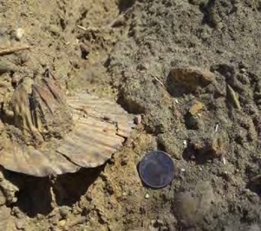
Patinopecten Zone photograph 1 (note quarter for scale)

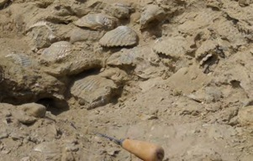
Patinopecten Zone photograph 2 (wooden handle is about 12 cm long)

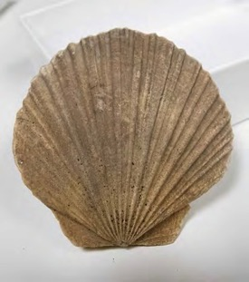
Patinopecten Zone photograph 3 (shell from top to bottom is 7 cm long)

Use the box for sketches of fossils, features of the outcrop, and/or for written explanations to the questions.

Fossils of the Macoma Zone
How many fossils are visible in photograph 1 and what do they look like? Can you see any features on the shells or identify any types of familiar animals? Look at the rocks surrounding the fossils. What do you notice about these rocks in terms of color, layers, and sizes of sand grains? Zoom into a high resolution photograph from this section and find the same coin for scale.
Notice the physical appearance of the individual Macoma shells in photographs 2 and 3.

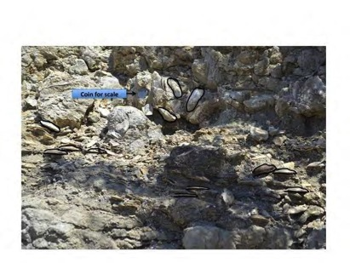

Macoma Zone photograph 1 (note quarter for scale)

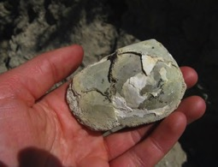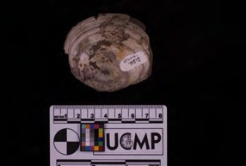
Macoma Zone photograph 2 Macoma Zone photograph 3 (scale bar in cm)

Use the box for sketches of fossils, features of the outcrop, and/or for written explanations to the questions.

Fossils of the Siphonalia Zone
Use photographs 1 and 2 from this zone to observe the sandstone rocks found here. What do you notice about these rocks in terms of color, layers, and sizes of sand grains that is different from the sandstone in the other zones of the Etchegoin Formation?

Using photographs 3 and 4, can you describe some features of the shell in terms of the series of bumps that are visible? How do the fossils in this zone compare with those of the Macoma Zone? Think about the types of fossils in terms of clams or snails, and the sizes of fossils.

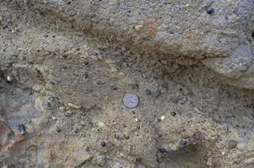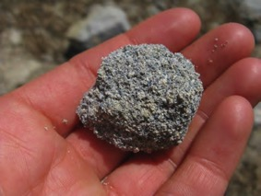
Siphonalia Zone photograph 1 Siphonalia Zone photograph 2

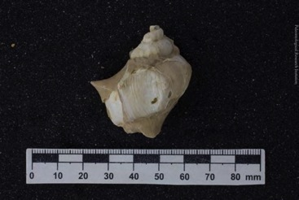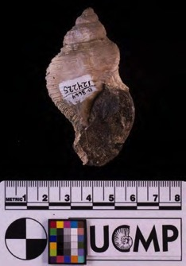
Siphonalia Zone photograph 3 (scale bar in mm) Siphonalia Zone photograph 4 (scale bar in cm)

Use the box for sketches of fossils, features of the outcrop, and/or for written explanations to the questions.

Fossils of the Pseudocardium Zone
Can you describe the rocks that occur in this section in terms of color and other visible features you see in photograph 1? Are the fossils big enough to see from this distance? How do the rocks in this zone similar to those of the Siphonalia Zone?

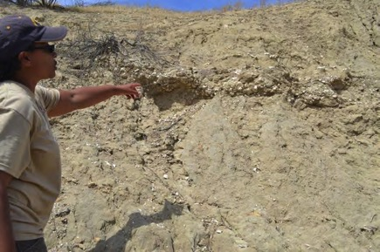
Pseudocardium Zone photograph 1

The main fossil clam from this zone is called Pseudocardium, which means “false heart,” and it has a number of distinctive features. This clam is rather different from the Patinopecten and Macoma clams. What are some of the differences you can notice in terms of size, shape, and thickness of shell between these clams?

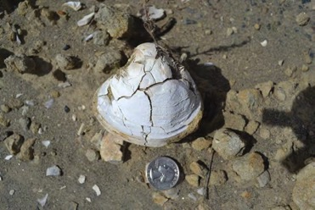
Pseudocardium Zone photograph 2

Photograph 3 shows common fossils from the Pseudocardium Zone. The fossil labeled A is a barnacle, fossils B, C (Pseudocardium), and D are clams, and finally fossil E is a sand dollar. What are some characteristics of these shells in terms of ribs (ornamentation), size, and shape? How do they compare with the fossils on the Siphonalia Zone? Are there noticeable differences that you can describe?

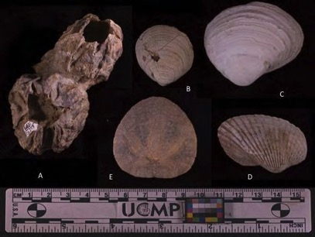
Pseudocardium Zone photograph 3 (scale bar in cm)

Use the box for sketches of fossils, features of the outcrop, and/or for written explanations to the questions.

Living Sand Dollars and Living Scallops
So far we have learned about fossil assemblages of invertebrate animals from the Etchegoin Formation. Does this lead you to any hypotheses, or ideas, about the ancient ocean conditions of the Kettleman Hills? As you watch this video of living scallops, think about and answer the following questions:

- What are some unique features about the living habits of scallops? Do they live in the ocean, or do they live in lakes?

- Do you notice any distinguishing features of scallop shells that you can use to recognize them and tell them from the other types of clams we have seen?

- The hard shell of the scallop can also be a place where other animals (like barnacles, photograph 1 below) attach called bioerosion. Knowing this, can you now find other evidence of

bioerosion in pictures of fossils from the Kettleman Hills?

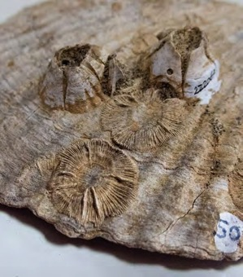
Scallop (Patinopecten) shell with barnacles

Fossils of the Pecten Zone
The next younger formation above the Etchegoin Formation is the San Joaquin Formation. Within the San Joaquin Formation is the Pecten Zone, named for the fossil scallop. As you view shells of Pecten, in the two photographs below, what are some similarities and differences you can notice in terms of size and shape between the variety of fossil scallops in this zone and the Patinopecten Zone?

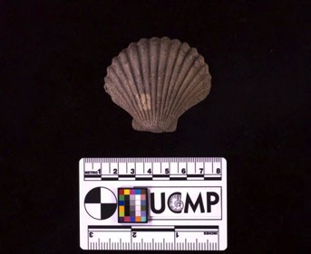
Pecten Zone photograph (scale bar in cm)

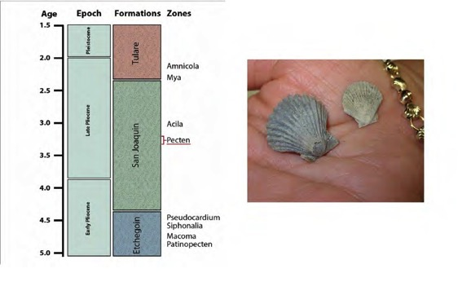

Use the box for sketches of fossils and/or for written explanations to the questions.

Fossils of the Acila Zone
As you examine photographs 1-5 in the Acila Zone (photographs 1-3 are below), how are the rocks in this zone similar or different from those in earlier zones in terms of coloring and layering? How are the fossils in this zone similar or different from those in the Etchegoin Formation in terms of size, shape, and thickness? Do you see any evidence of bioerosion?

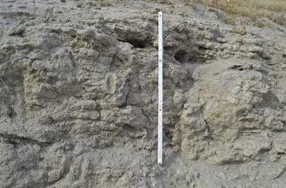
Acila Zone outcrop, photograph 2 (staff is 1 m)

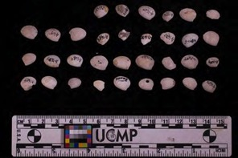
Acila Zone, photograph 1 (scale bar in cm)

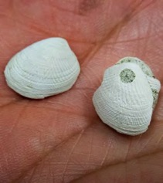
Acila Zone, photograph 3 (width of shell is approximately 1 cm)

Use the box for sketches of fossils, features of the outcrop, and/or for written explanations to the questions.

Fossils of the Amnicola Zone
The Tulare Formation is the uppermost and youngest layers of rocks in the Kettleman Hills. The Amnicola Zone in the Tulare Formation is named for a freshwater snail. As you view photographs 1 and 2 from from this zone (photograph 2 is below) what do you notice about the sandstone that is different from the sandstone in the older San Joaquin and Etchegoin
formations? Can you describe the rocks found in this section in terms of color and other features?

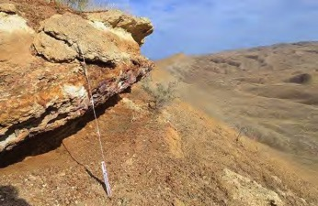
Amnicola Zone outcrop, photograph 2 (staff is 1.5 m)

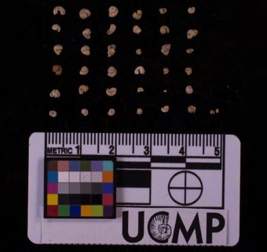
Amnicola Zone, photograph 4 (scale bar in cm)

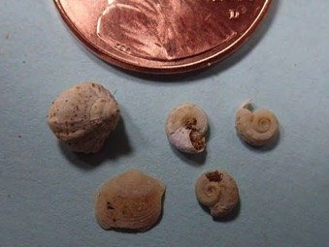
Amnicola Zone, photograph 6 (note penny for scale)

Use the box for sketches of fossils, features of the outcrop, and/or for written explanations to the questions.

You have likely noted the changes in sizes of fossils we viewed from the Kettleman Hills. Measure and record them here before moving to the next section.

Formation | Zone Marker | Common Name | Size in cm or mm (long dimension) | Notes
Etchegoin | Patinopecten | scallop/clam
 | Macoma | clam
 | Siphonalia | snail
 | Pseudocardium | clam
San Joaquin | Pecten | scallop/clam
 | Acila | clam
San Joaquin | Amnicola | snail

Environmental Interpretations of the Kettleman Hills between 1-4 million years ago

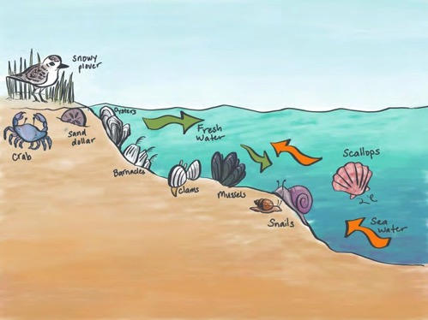
Schematic drawing of modern organisms in shallow water

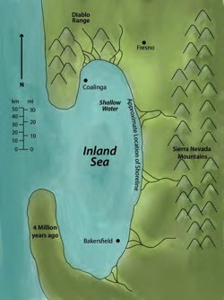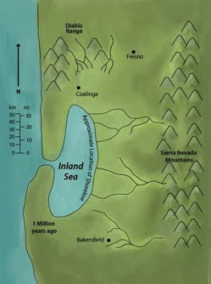
Generalized maps of the Kettleman Hills area in Central California 4 million years ago (left) and 1 million years ago (right)

As you look at the generalized diagrams in this final section, remember that fossils can help us in interpreting past environments. To apply fossils in this way we need know how their close, modern day relatives live. Do you recognize any Kettleman Hill fossils in the drawings of modern organisms shown underwater? Think about the places where animals live and the conditions of the water in those environments. Was the Kettleman Hills environment freshwater or saltwater? Was it a lake or the ocean?

What evidence from the fossil record supports the change of environment between 1 and 4 million years ago? Think about the fossils we saw on our journey through time and the environments those fossils occupied while they were living animals. Use the space provided to explain the changes and relate it to the sizes of fossils you measured from each of the formations in the Kettleman Hills.

