**Field to Museum**

**https://arcg.is/1m9ivm**

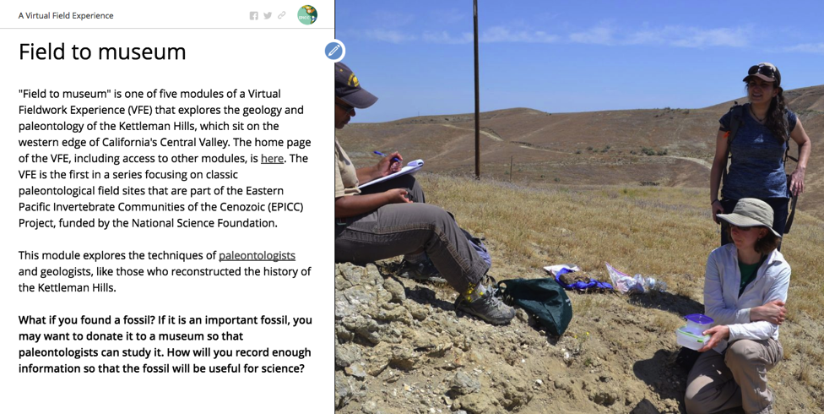

# Lesson plan details

Lesson plan details

Overview

Overarching question

Driving question for students

Module description

Specific intended learning outcomes

Prior student knowledge

Possible preconceptions and misconceptions

NGSS alignments

Student Worksheet Question 1

Student Worksheet Question 2

Student Worksheet Question 3

Student Worksheet Question 4

Student Worksheet Question 5

Student Worksheet Question 6

Student Worksheet Question 7

Student Worksheet Question 8

Student Worksheet Question 9

Student Worksheet Question 10

## 

## Overview

This module shows students how and why to collect fossils, including doing virtual fieldwork to describe the rocks that surround the fossils. This module is written with high school earth science classes in mind, though it could be adapted for undergraduate geoscience classes as well.

The module uses the slides from the Storymap “Field to Museum.” The Storymap is written for students and is accompanied by a student worksheet with exercises to check understanding of the module text. In this module, the field notebook is used to write down answers to questions and make drawings. Students could work quietly and teachers could check their answers at the end or teachers could ask the questions aloud, give students a few minutes to respond and then give feedback on those responses.

Of course, just as there are many possible lessons with any fossils, there are many lessons you might create using the images presented here that go beyond this exercise!

## Overarching question

How do paleontologists collect a fossil so that it will be useful for science?

## Driving question for students

***How will you record enough information so that the fossil will be useful for science?***

## Module description

Imagine you found a fossil. Students will learn why fossils are collected and how to get permission to collect fossils. They will record their observations about a fossil they discovered in a field notebook, and take photos to document these observations. Students will learn to record their location using a variety of methods, how to safely collect, label and transport a fossil. Finally, they will learn how museums preserve fossils to make them available to future researchers and that fossil data is available online.

Length of activity

If done in full 45 minutes, but can be adapted to 20 minutes

## Specific intended learning outcomes

* Students will be able to list steps to take before collecting a fossil.
* Students will be able to describe how to label and wrap a fossil for safe transport.
* Students will be able to describe sediments and fossils observed in the photos and how they are related.

## Prior student knowledge

* It would be helpful for students to have an introduction to fossils and to rocks

## Possible preconceptions and misconceptions

* All fossils discovered should be collected.
* You are allowed to collect fossils anywhere you find them.
* Scientists don’t need to understand the sediment surrounding the fossil in order to make hypotheses about the environment during the time the fossil lived.

## NGSS alignments

The framework guiding the NGSS is drawn from three interconnected [dimensions](https://nextgenscience.org/) of learning: Science and Engineering Practices, Cross Cutting Concepts, and Disciplinary Core Ideas. In combination these dimensions help form each standard or Performance Expectation.

The five Kettleman Hills VFE modules complement each other and provide rich and engaging experiences in life science and Earth systems science. Four of the teacher guides to the Kettleman Hills VFE modules detail the middle and/or high school Performance Expectations, Science and Engineering Practices, Cross Cutting Concepts, and Disciplinary Core Ideas. By nature of the activities in the Field to Museum module, the emphasis is on Science and Engineering Practices, in particular Practice 3 - Planning and Carrying Out Investigations.

1. Asking Questions and Defining Problems

2. Developing and Using Models

**3. Planning and Carrying Out Investigations**

4. Analyzing and Interpreting Data

5. Using Mathematics and Computational Thinking

6. Constructing Explanations and Designing Solutions

7. Engaging in Argument from Evidence

8. Obtaining, Evaluating, and Communicating Information

In grades 6-8, the stated aim of Practice 3 is as follows and activities in the Field to Museum module are closely aligned:

* [Planning and carrying out investigations in 6-8 builds on K-5 experiences and progresses to include investigations that use multiple variables and provide evidence to support explanations or solutions.](http://www.nap.edu/openbook.php?record_id=13165&page=59)

In order to carry out the investigations at stated in Field to Museum, we recommend you guide the student to:

* Conduct an investigation to produce data as the basis for evidence that meet to goals of the investigation
* Collect data to serve as the basis for evidence to answer scientific questions

--------------------------------------------------------------------------------------------------------------------------------

Text in blue is from student worksheet. Text in black is suggested answers and guidance for teachers using this exercise.

## Student Worksheet Question 1

1. Why do paleontologists collect fossils? Should you collect every fossil you find? Why or why not? Write your answer in your field notebook.

From the VFE module text in 1), paleontologists collect fossils as evidence to support their hypotheses.

From the VFE module text in 1), collect only what you need because other people will want to see or study the fossils, too!

## Student Worksheet Question 2

1. If you are on US Forest Service land, can you collect common invertebrate fossils? If you are on US Forest Service land, can you collect vertebrate fossils? Can you collect any fossils on National Park Service land? Write your answer in your field notebook.

Yes, you can collect common invertebrate fossils on US Forest Service land.

No, you cannot collect vertebrate fossils on US Forest Service land unless you are working on a scientific project and have a permit.

No, you cannot collect any fossils on National Park Service land unless you are working on a scientific project and have a permit.

## Student Worksheet Question 3

3a) Imagine you and two friends went to the Kettleman Hills to look at fossils. (Please note that the Kettleman Hills localities are on private land and no longer available to collectors.) Write down your name, the name of those with you, today’s date, what the weather is like today (warm or cold, sunny or rainy) and the location: *Pseudocardium* zone of the Etchegoin Formation.

Answers will vary.

3b) Choose a photograph of exposed rocks with a person or tool for scale from this webpage:

<https://flic.kr/s/aHskX78qoh>

This Flickr album includes 28 photos, all from the *Psuedocardium* zone of the Etchegoin Formation field locality.

For example, I chose the photo below:



Write down your observations about the sediment and the fossils. Do you see the layers of white shells in between layers of brown sedimentary rock in this photo? Draw lines on either side of the layers of white shells.

The lines in the photo above outline two prominent shell beds. There are also a lot of shells visible below the lower shell bed, but they have been moved from their original location and no longer constitute a shell layer.

Unless students go to the online version of this photo (<https://www.flickr.com/photos/44458789@N04/35312903925/in/album-72157682069726724/>), they will have a difficult time making detailed observations about the sediment or fossils. However, students could still describe the color of the sediment (light brown). If you zoom in using the online version of the photo, students may be able to see that no individual sand grains are visible, suggesting this might be made up of silt or clay rather than sand. The fossils in the photo are bivalves, but this might be difficult for students to determine. They might describe their color (white), appropriate size (using the meter scale in the photo) or draw the shape of one fossil.

3c) Make a drawing of the outcrop in your notebook. Label any fossils you can see. You may want to draw a simple shell as a symbol for where fossils are found in your drawing, see the example below.



Drawing for my example would look like:

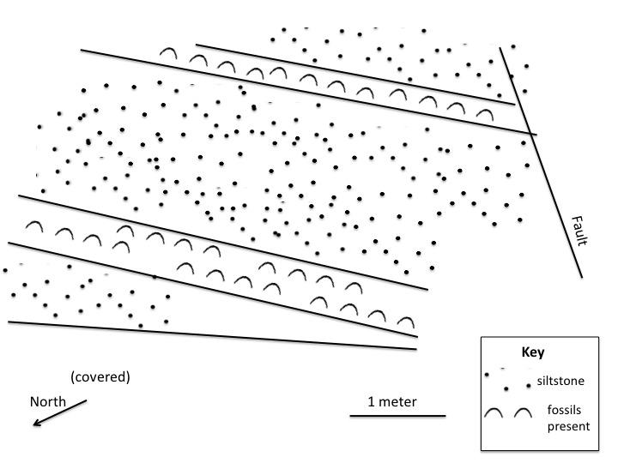

Or a labeled photo (if a printer is available, students could print out their chosen photo and make the drawing on top of it) would look like:

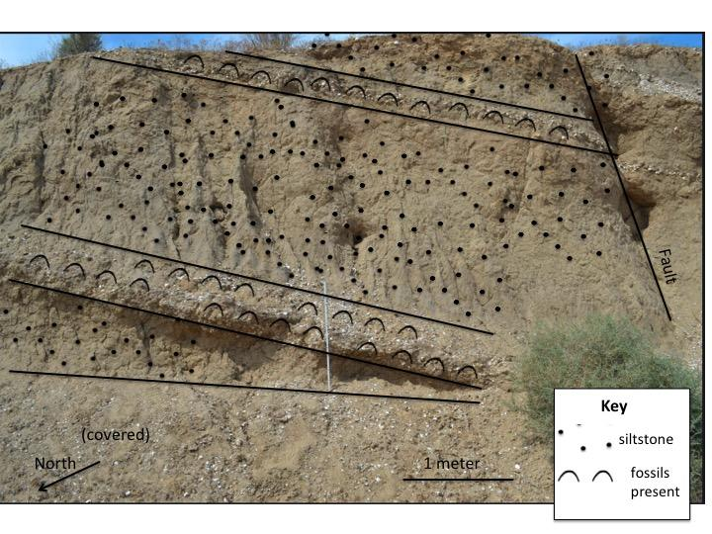

## Student Worksheet Question 4

4a) Find two other photos of the *Pseudocardium* zone outcrop on this page:

https://flic.kr/s/aHskX78qoh

Explain why you chose those photos including whether the photos include a scale and features that won’t move over time.

Students should choose photos that have scale included (there are some that don’t have scale). The photo I chose above does not include topographic features in the background, so it would be preferable to choose something like:

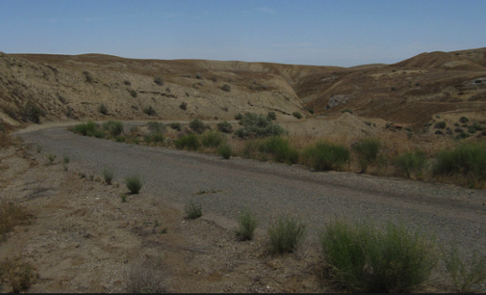

or ideally:

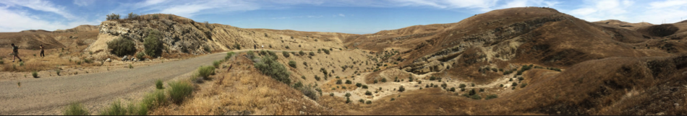

4b) Find two close-up photo of fossils from the *Pseudocardium* zone outcrop on this page:

https://flic.kr/s/aHskX78qoh

Explain why you chose those photos including whether the photos include an object for scale.

As in above, students should choose fossil photos with scale and with the fossil in focus such as:

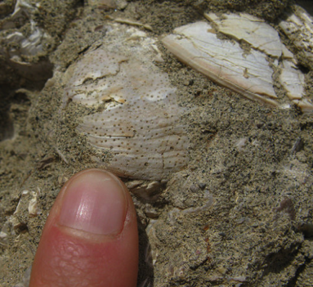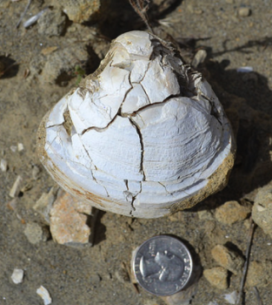

## Student Worksheet Question 5

5) Write down captions for the four photos you chose above. Use the information from your field notebook and choose yourself or one of your two friends as the person who took the photos or is in the photos. Make sure you include the date and the time the photo was taken. Describe the rocks or fossils you can see in the photo. The rock exposures are from the *Pseudocardium* (a fossil bivalve) zone of the Purisima Formation.

Students should use today’s date and time for the exercise. An example can be found in the module: Photo by E. Clites, April 19 2016, 3pm. J. Bean for scale. The white objects you can see in the brown rock are shell-filled layers within the Pseudocardium zone of the Etchegoin Formation.

If you have a printer, print out one of the outcrop photos and draw an arrow showing where there are fossils visible.

This is an optional variation if a printer is available. This is an example of the type of photo museums archive to make sure they know where the fossil was collected.

## Student Worksheet Question 6

6) If you have internet access, visit Google Earth <https://www.google.com/earth> and enter “Kettleman Hills” where the magnifying glass signifies “search” and see what the area looks like. Find an area with exposed rock or sediment where you could find a fossil. If you have a printer, print out a picture and mark the place you “collected” the fossil with a small circle.



Example screenshot of exposed rock area with “collection” spot marked with black dot. Students should include scale and North arrow in their screenshot.

## Student Worksheet Question 7

7) Choose one of your two close-up photos of fossils from the *Pseudocardium* zone. Describe the rocks above, below and near the fossil in your field notebook. Does your fossil have any parts that look delicate? Based on the video of fossil collecting, describe how you would wrap the fossil in your photo.

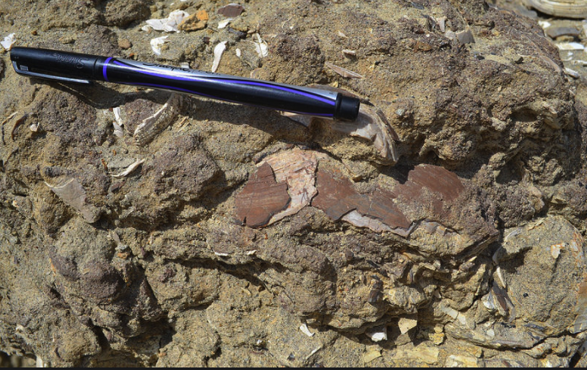

This photograph would be a good choice to describe, as you can see the sandstone grains surrounding the fossil.

This fossil is already broken, so it would likely need to be wrapped in toilet paper or other soft material to cushion it once collected.

## Student Worksheet Question 8

8) Write down what your field number for this locality would be. Remember to use your initials, the date and the fossil’s position in the list of fossils collected that day. Look at the labeling guide and explain where you would a number on your fossil, in order to avoid covering any features used for identification.

Example field number from the module: ECC 11-25-2016 #1

Students could state, for example, that bivalves should be labeled on the inside of the valve or shell.

## Student Worksheet Question 9

9a) Is your fossil an important fossil? What evidence supports your claim? (Hint: use the [What is a Fossil?](http://arcg.is/2iGHLkc) Module to try to identify your fossil.)

Answering this question may require more time that available for the exercise. Teachers could suggest some simpler questions such as: Is your fossil complete? Could your fossil be an important fossil? What evidence supports your claim?

Students could answer that fossils don’t have to be complete to be important.

Alternatively, you could use the fossil photo and follow the steps of the What is a Fossil? Module to find out more about what the fossil is and whether it might be important.

The goal of this question is mainly to see whether students understood some of the ideas presented in the module about how they would determine if the fossil was important.

9b) Would you choose to donate your fossil to a museum? Why or why not? If not, what would you do with the fossil?

Some possible answers:

Yes, I would choose to donate my fossil to a museum because it is scientifically important.

Yes, I would choose to donate my fossil to a museum because I want it to be available for study by scientists and students in the future.

No, I want to keep the fossil for myself and bring it home.

## Student Worksheet Question 10

10) View the online record for the fossil in the photo. What county was this fossil collected in? What formation is this fossil from? What is the name of the fossil (hint: look at the left side of webpage for the genus and species name)?

This fossil was collected in Kings County. It is from the Etchegoin Formation. The name of the fossil is *Pseudocardium* *densatum*.

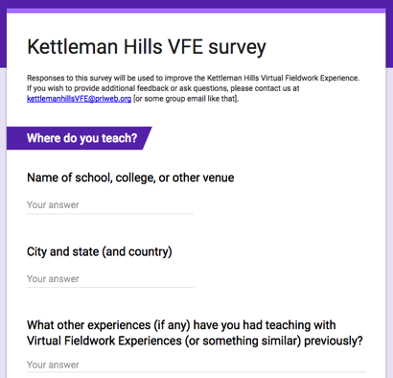

**We would be grateful to receive *feedback* on how we could improve this virtual fieldwork experience.** *If you can spare about 10-15 minutes, please click* [*here*](https://docs.google.com/forms/d/e/1FAIpQLSfA0t1c7333e_BikDrtlw1UOWxIBFtUHNv8gN9sroeWYH98ew/viewform)*.* Thank you very much.